**Establishing the Jupyter Environment on Windows 7**

Author: Kai-Tao Yang ([k.t.yang@uvt.nl](mailto:k.t.yang@uvt.nl)), Data Engineer at JADS

We establish the Jupyter environment using Anaconda (<https://www.continuum.io/downloads>) in two steps: (1) install Anaconda; (2) install Nbextensions.

# Anaconda

## Download anaconda:

According to the bit of your Operating System, download the 64-bit or the 32-bit Anaconda from the following links:

64-bit: <https://repo.continuum.io/archive/Anaconda3-4.2.0-Windows-x86_64.exe>

32-bit: <https://repo.continuum.io/archive/Anaconda3-4.2.0-Windows-x86.exe>

## Install anaconda:

**Right-click** the .exe file of anaconda, and **run as administrator**.

Install for **All Users** as shown below

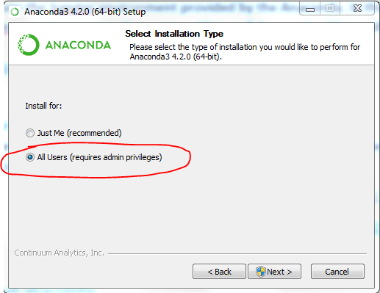

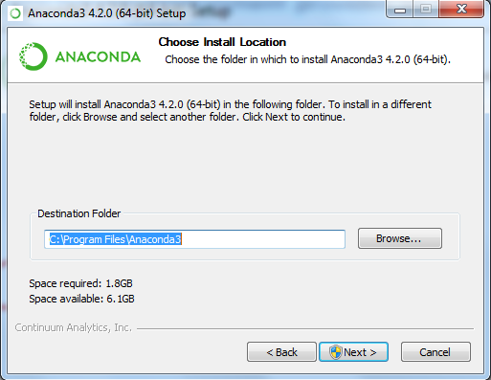

## Launch the Jupyter

After installing anaconda, you can launch Jupyter in two ways: (1) through the Anaconda Navigator; (2) through the command window.

### Launch the Jupyter through the Anaconda Navigator

Start=>All Programs=>Anaconda3=> Anaconda Navigator

Click the “**Launch**” button below Jupyter as shown below.

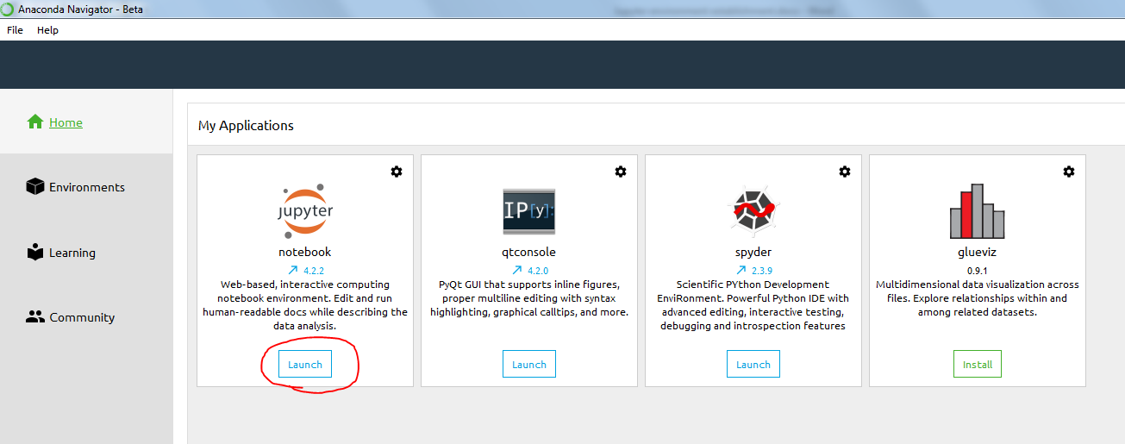

### Launch the Jupyter through the command window

Open a command window, and run the following command:

jupyter notebook --port 9999 --notebook-dir D:\test

Where D:\test is the directory for the starting folder of the Jupyter (you can change this directory to what you want).

Note: please create a folder named “test” in D: before you run the above command.

### Test the Jupyter

After launching the Jupyter, you browser will automatically open a page as show below:

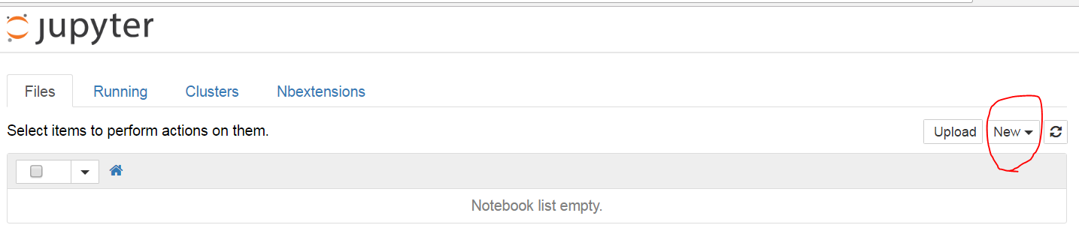

Click the **New** drop-down button, and then chose the **Python[root]**. Type in the following command:

print("Hello World!")

Press **Ctrl+Enter** to execute the command, you will see the result shown below:

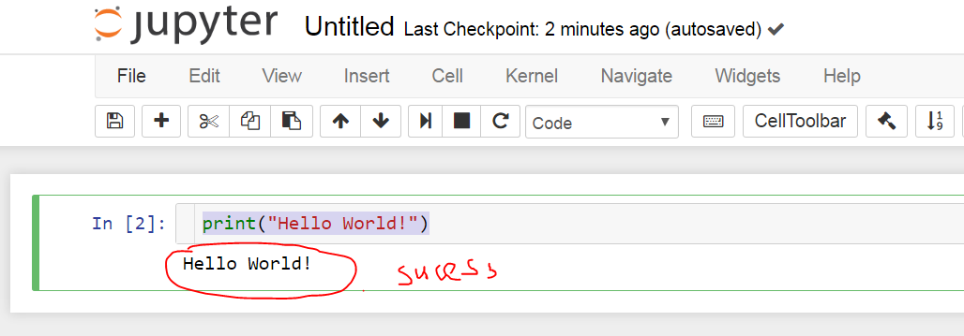

If you can print out “Hello World!” as shown above, then the Jupyter environment is established successfully.

Note: The IE browser is not well-supported by Jupyter, it is recommended to install Google Chrome, and set Google Chrome as the default browser.

# Nbextensions

After establishing the Jupyter environment, we then install the Nbextensions which contain some additional handy features.

**Right click** the command window and **run as administrator** as shown below:

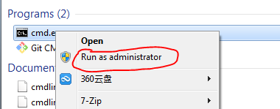

Run the following command in the command window:

conda install -c conda-forge jupyter_contrib_nbextensions

Close the Jupyter and re-launch it:

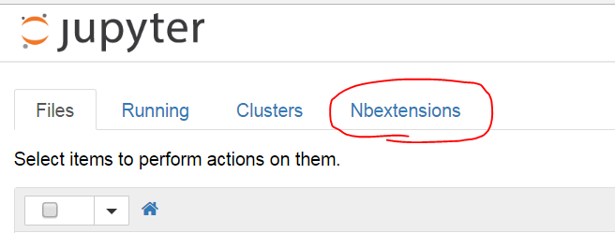

If you see the tab **Nbextensions**, then you installed the Nbextensions successfully!